**Listening N° 2: How do you keep healthy?**

**Name: Class: Date:**

Identificar en los textos escuchados:

* Tema e ideas generales
* Información específica asociada a personas, lugares, tiempo y acciones.
* Palabras, familias de palabras, expresiones de uso frecuente y vocabulario temático.

**Objetivo de Aprendizaje 2**



**I. LOOK** at the pictures and **WRITE** the action under the correct picture.

eat healthy food – play any sport – practice physical exercises

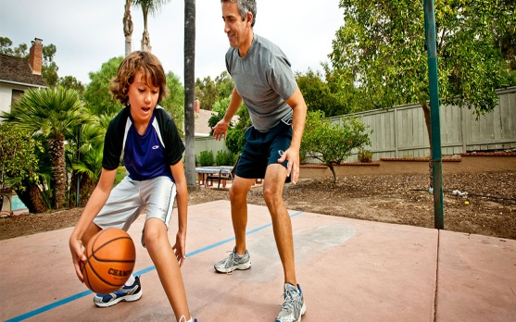

b)

a)

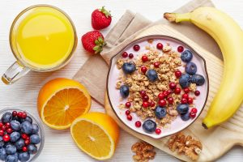

c)

******II. WATCH** the video and **TICK** all the pictures related tothe topic of the video. Then **ANSWER** the question.

(Taken from: <https://www.youtube.com/watch?v=_VczK2zV2sE>)

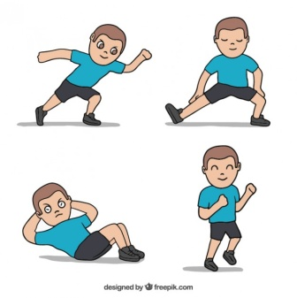

**1**

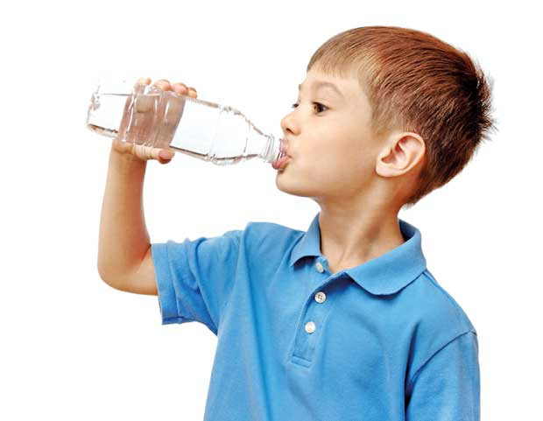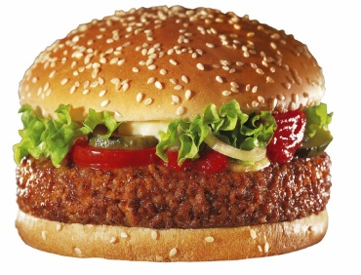

****a) What is the video’s main idea?

------------------------------------------------------------------------------------------------------------------------------------------------------------------------------------------------------------------------------------------------------------------------------------------



**III. WATCH**  the video and **COLOR** *Yes* or *No* according to the answer.

|  |  |  |  |  |
| --- | --- | --- | --- | --- |
| **YES** |  | | **NO** | |
| **YES** | | **NO** | |
| **YES** | | **NO** | |
| **YES** | | **NO** | |
| **YES** | | **NO** | |
| **YES** | | **NO** | |

1. The video is about how to keep fit and healthy.
2. The video gives you some advices of healthy life.
3. You have to play indoor games in the evenings.
4. You have to sleep early.
5. We need energy to do many things.
6. The boy does different activities.

**IV. WATCH** the video again and **COMPLETE**  the chart with 5 actions the boy does to keep the body fit and healthy.

|  |
| --- |
| **ADVICES TO KEEP YOU FIT AND HEALTHY** |
| 1. Wake up early in the morning. |
|  |
|  |
|  |
|  |
|  |



**V. WRITE** from each action (1-4) next to the corresponding picture.

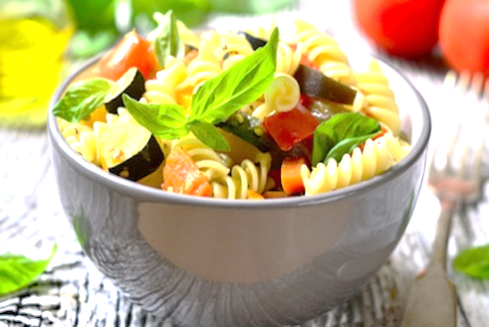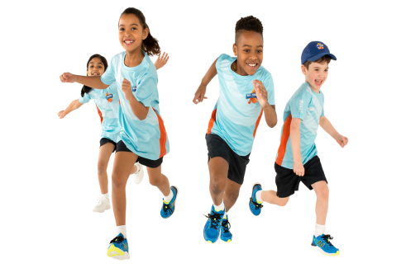



**4.** keep fit

**3.** eat healthy

**2**. drink milk

1. sleep Early

**VI. DRAW**  and **WRITE** 2 things from the video you do to keep fit. **LOOK** at the example. **SHARE** C:\Users\Usuario\Documents\descarga.png your answers with your classmates.



**I eat healthy breakfast.**

a)



b)